🦾 Survivors
Game Rules
Character Sheet Template
(click -> open preview -> Ctrl+A -> copy-paste under the last survivor and edit according to the Character Creation rules)
OR just take one of the Unoccupied Character slots below!

Dead Panic Content Download

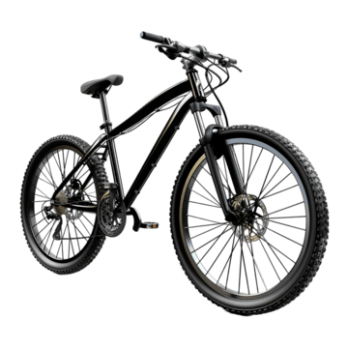 | ikenized  GM

The Survivors

 |  |  |  | Kaela Aeona |  |  |  |  | Smiles
 |  |  |  | The heiress to a family-owned antiques store who just wanted ONE NICE LITTLE VACATION. Can’t even have a VACATION without the APOCALYPSE STARTING. This frustration shall fuel ALL the violence.
 |  |  |  | Attributes |  |  | Danger Level:  Worried |  | Hit by firework sparks.
 |  |  |  | Form |  | 5
 |  |  |  | Endurance |  | 2 (2) | Buffs
 |  |  |  | Awareness |  | 1
 |  |  |  | Scavenging |  | 3 (4) | Debuffs |  | -1 Endurance from firework abuse
 |  |  |  | Technology |  | 4
Special Perks |  |  |  |  |  | Trauma
Not On My Watch! |  | Once per round, get a free shot at an enemy that attacks a Survivor as long as both are in range of the user’s weapon. |  |  |  | Can’t Swim! |  | Will sink like a log in deep water. -1 to all stats while in water at chest or higher.  + 2 Attribute Points

💼Inventory
Item Name  <Item Icon> |  |  | Item Description. |  |  |  |  |  |  | Big weapon slot.
Sushi Knife  <Item Icon> |  |  | Slice ‘em up!  2 DMG  Durability: 4  Range: Engaged  DC 5 |  |  |  |  |  |  | Small weapon slot.
Item Name  <Item Icon> |  |  | Item Description. |  |  |  |  |  |  | Usable item slot.
Item Name  <Item Icon> |  |  | Item Description. |  |  |  |  |  |  | Usable item slot.

 |  |  |  | Camille O’Neil |  |  |  |  | Redfield
An office worker with a previously monotonous life.
Until the zombie apocalypse added a wrench in society.
 |  |  |  | Attributes |  |  | Danger Level:  Worried |  | Scratched on the shoulder.
 |  |  |  | Form |  | 2
 |  |  |  | Endurance |  | 5 | Buffs
 |  |  |  | Awareness |  | 3
 |  |  |  | Scavenging |  | 2 | Debuffs
 |  |  |  | Technology |  | 3
Special Perks |  |  |  |  |  | Trauma
Flexibility |  | When escaping a horde’s grab, use your Endurance attribute instead. |  |  |  | Losing one’s marbles |  | -1 to all stats when in “Danger” health state.  + Special Perk
Overtime |  | You can reroll 3 failed action per sessions

💼Inventory
Surf Board  <Item Icon> |  |  | Surf’s up, dude!  Range: Engaged  Durability: 4  DMG: 2  Allows you to take cover against  Frontal Attacks |  |  |  |  |  |  | Big weapon slot.
<Item Icon> |  |  |  |  |  |  |  |  |  | Small weapon slot.
Nothing  <Item Icon> |  |  | Nothing is here |  |  |  |  |  |  | Usable item slot.
Item Name  <Item Icon> |  |  | Item Description. |  |  |  |  |  |  | Usable item slot.

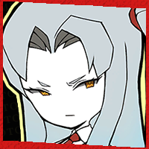 |  |  |  | Angela Wolf |  |  |  |  | Detectiv
 |  |  |  | Manager of the hotel. Really doesn’t like the fact it’s overrun by zombies.
 |  |  |  | Attributes |  |  | Danger Level:  Worried |  | Hit by firework sparks.
 |  |  |  | Form |  | 2
 |  |  |  | Endurance |  | 2 | Buffs
 |  |  |  | Awareness |  | 5
 |  |  |  | Scavenging |  | 3 | Debuffs |  | -1 Endurance from firework abuse
 |  |  |  | Technology |  | 3
Special Perks |  |  |  |  |  | Trauma
This Area is Under My Service! |  | Automatically senses danger in every new area, still has to roll awareness to identify the cause.

💼Inventory
Golf Club  <Item Icon> |  |  | Bat 'em up!  1 DMG  Durability: 4  Range: Engaged  DC 4 |  |  |  |  |  |  | Big weapon slot.
Sushi Knife |  |  | Slice ‘em up!  2 DMG  Durability: 4  Range: Engaged  DC 5 |  |  |  |  |  |  | Small weapon slot.
Item Name  <Item Icon> |  |  | Item Description. |  |  |  |  |  |  | Usable item slot.
Item Name  <Item Icon> |  |  | Item Description. |  |  |  |  |  |  | Usable item slot.

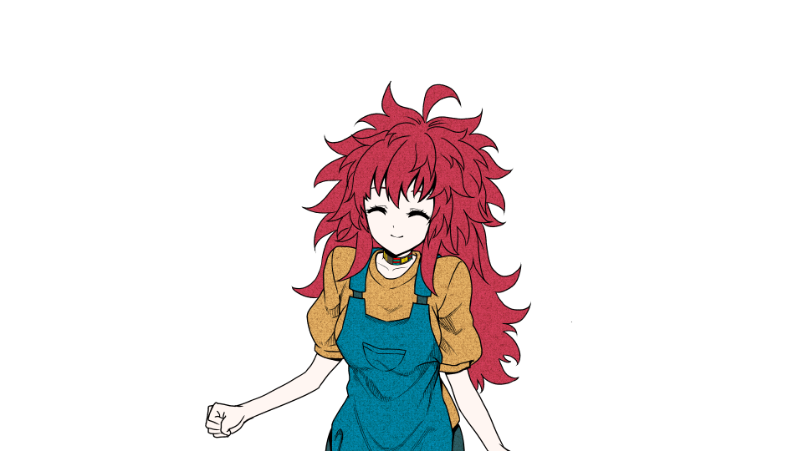 |  |  |  | Tru Stem |  |  |  |  | RJ
 |  |  |  | A devoted therapist who has 2 goals. To help others through their trauma and to follow their beliefs. Even if their beliefs are questionable to the outside world
 |  |  |  | Attributes |  |  | Danger Level:  Worried |  | Her wrist is Slit
 |  |  |  | Form |  | 2
 |  |  |  | Endurance |  | 3 | Buffs |  | Bloody Gamble (+1 to all)
 |  |  |  | Awareness |  | 1
 |  |  |  | Scavenging |  | 4 | Debuffs |  | Injured Wrist (-2 Tech)
 |  |  |  | Technology |  | 5(3)
Special Perks |  |  |  |  |  | Inventory
Divine Intervention |  | When a player is suffering from any debuff, Tru will attempt to pray to relieve them of the trauma.  Flip a coin, of heads tru is debuffed instead  If tails spend one quick action |  |  |  | Lighter |  | Small weapon slot.
Bloody Gamble |  | Tru uses the weapon she currently has to injure herself. In exchange everyone gains +1 to all stats for a single turn of combat. |  |  |  | Firework |  | It’s not even New Year’s Eve yet…  Reduces horde level by 1.  Range: Engaged  DC 4
 |  |  |  |  |  | Firework |  | It’s not even New Year’s Eve yet…  Reduces horde level by 1.  Range: Engaged  DC 4
Trauma
Trauma Name |  |  | Trauma description.
Divine Devotion |  |  | When injured to Danger level, must spend one slow action praying for protection |  |  |  |  |  |  | +special perk

Briella Min

Temporarily using this subtab as an archive
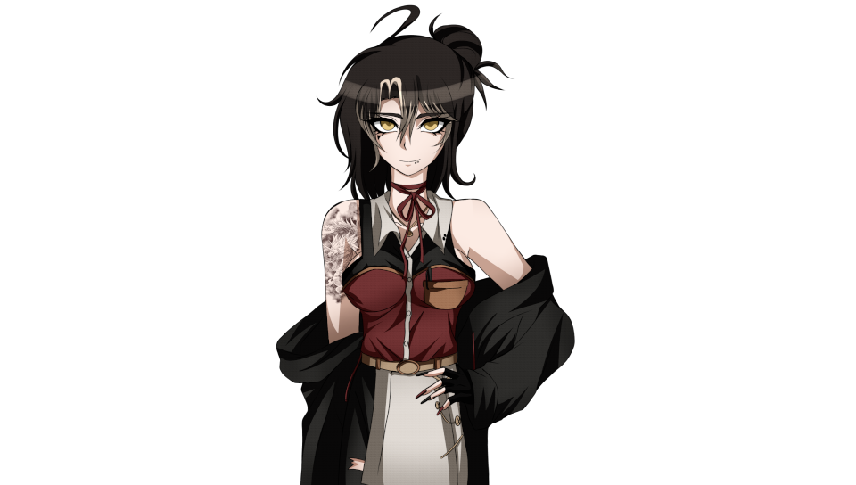 |  |  |  | Briella Min |  |  |  |  | Scruffy the Magical
 |  |  |  | A barista who’s been working as best she can to survive after her cafe was ransacked by zombies. Overreliant on caffeine to get through a day.
 |  |  |  | Attributes |  |  | Danger Level:  Perfect |  | Describe wounds here.
 |  |  |  | Form |  | 4
 |  |  |  | Endurance |  | 3 | Buffs
 |  |  |  | Awareness |  | 3
 |  |  |  | Scavenging |  | 2 | Debuffs
 |  |  |  | Technology |  | 3
Special Perks |  |  |  |  |  | Trauma
The Barista’s Signature |  | Can use chocolate, coffee beans and water to make a serving of Signature Coffee when using brewery equipment.  Signature Coffee (Buff)  +2 Awareness  +1 Endurance  Duration: 6 Turns  If a survivor other than The Barista consumes a Signature Coffee, they gain the debuff ‘Caffeine Crash’ upon a singular consumption instead. |  |  |  | Caffeine Crash |  | Once the effects of 'The Barista's Signature' has ended, gain this debuff.  All stats are temporarily reduced by -1 if two Coffees have been consumed. For every Signature Coffee consumed after the first two, reduce all stats by another -1.  This debuff will only be cleared once the Survivor has taken a long rest (eight hours of uninterrupted sleep).  + Special Perk
Care for a Coffee Break? |  | Start with a Portable Brewer in the Big Weapon slot.  For every time a coffee is brewed, use up one charge. Once the charge hits zero (0), it must be recharged in an electrical socket for two turns to gain back a single charge.

💼Inventory
Portable Brewer |  |  | Grab a cup o’ joe on the move!  Durability 2  Damage 0  Charge 3/3  May be used to store water. |  |  |  |  |  |  | Big weapon slot.
Item Name  <Item Icon> |  |  | Item Description. |  |  |  |  |  |  | Small weapon slot.
Item Name  <Item Icon> |  |  | Item Description. |  |  |  |  |  |  | Usable item slot.
Item Name  <Item Icon> |  |  | Item Description. |  |  |  |  |  |  | Usable item slot.

📏 Rules
Template Link Please keep the template doc link if you are to use this template. You are free to remix, modify and adapt this doc to your liking as long as you credit the author(s). Doc and mechanics created by Crystalwarrior.

Undead Panic
Welcome to the Zombie Apocalypse! Shamble shamble🧟‍♀️🧟‍♂️

Game Rules

General
- Roleplay Rules - Read this! This is important!

Character Creation
- Select All and Copy this character sheet, paste it into the Survivors tab and fill out these sections (or fill it out as its own doc and send it to the GM if this doc is in View Mode):
  - Character Name - your character's name. Can be anything
  - Player Name - your OOC name.
  - Character Description (optional) - a brief summary of the character.
  - Character Image (optional) - image of the character. Can just be their sprite.
  - Attributes - 15 points to spend at initial creation. Minimum of 1 in each stat, maximum of 5 in any particular stat.
Attributes (min 1, max 5) |  | Explanation
Form | 1 | Your physical fitness and strength. Ability to dish out punishment, using weapons, pushing, pulling and carrying hard objects.
Endurance | 2 | Dodging attacks. Running from pursuers. Overcoming pain, tolerance to substances, poisons.
Awareness | 3 | Detecting ambushes. Identifying hidden threats.
Scavenging | 4 | Discover useful items, searching.
Technology | 5 | Mechanisms and crafting. Also frequently used for firing guns.
Points Total | No more than 15
  - Special Perks - Your starting perk, as described below (rule 4)
  - Trauma - either a debilitating injury, loss of limb, or an action your character will absolutely refuse to do, or a massive debuff to a stat like -2, or loss of your other perk.
    - However, gain either 1 extra perk, or 2 points to spread on any of your attributes.
  - Inventory - Any items gained from your perk or collected during the game.
- Your character may be a custom. However, you must provide a link to your custom character.
  - Links must be provided before the sign-up deadline is reached. Otherwise you may be asked to switch to a base content character.
- Each character will gain one (1) unique perk at the start of the session. Examples of a perk include: sensing if there is danger whenever you enter a new area, gaining one extra inventory slot, starting with a specific item without needing to scavenge for it, an additional bonus in certain stat rolls, and whatever else the user may come up with.
  - The player may be able to freely come up with any kind of perk they want, so long as this perk is approved at the GM's discretion.
  - You are allowed to ask the GM for assistance in creating a perk.

Inventory Rules
- Survivors have a limited inventory. They may have:
  - 1 Big Weapon (axe, spear, sledgehammer)
  - 1 Small Weapon (knife, screwdriver, hammer)
  - 2 Usable Items (first-aid kit, bandages)
- Survivors may exchange items with each other, or put them on the ground.

Exploration

Overview
- Undead Panic is capable of being run using only a single area for the entire duration of the session, choosing to switch BG’s whenever the entire party moves together to a new location.
  - However, in the event that the party has chosen to be split up, the utilization of other areas is possible.
  - The GM may also prepare an explorable multi-area location for you, utilizing the area descriptions or the evidence system as necessary.
- During the exploration phase, there is no turn order on which survivor may go first. You are allowed to describe the action you wish to perform at any time.
- Survivors may be able to interact with their environment as they wish, whether it be scavenging, searching for information on a computer, boarding up the windows of a house, and so on. A GM will then ask you to roll if necessary. Rolls use one or several of the survivor attributes. The number must be equal to or higher than the Difficulty Check (DC) to see if your action passes. For example:
The Difficulty Check (DC) is 6. You are asked to roll Scavenging, which is 3 for you. In OOC you use:
/roll 1d6 +3
With the resulting roll being 3 + 3 = 6, your Scavenging action passes.
  - You do not need to roll for an action unless the GM explicitly tells you to do so.
  - If your roll doesn't pass (you roll under the DC) your action either succeeds with complications, or fails entirely. Only actions that may not be repeated can fail, and failure results in consequence.
As an example of a "succeed with complications" action:
if you kick open a jammed door, but you did not pass the DC, you still succeed in kicking it open. However, your leg gets caught inside the door. The complication becomes suffering an injury to your leg.
  - If asked, the GM must respond if the action can fail entirely, or succeed with complications.
- The exploration phase does not end if survivors encounter a single zombie - they may be ambushed, suffer injuries and dispatch straggler zombies. However, encountering a horde of zombies will result in the Combat Phase.

Combat

Overview
- When combat begins, initiative is decided by comparing each participant’s Form stat. If multiple Survivors have the same Form, they decide between each other who goes first (if no decision is reached, GM decides for them). After that, Combat alternates between Survivors and the Zombie Horde.
- Combat proceeds in turns. On each turn, every participant has access to 3 Action Points (AP).
  - Slow Actions cost 2 AP
  - Fast Actions cost 1 AP
- Combat ends only when:
  - All zombies are destroyed
  - All survivors are dead
  - The survivors escape the encounter

Slow and Fast Actions

Slow Actions (2 AP) include:
- Attacking
- Reloading a weapon
- Performing a major objective (e.g. refueling, rebooting a system)
- Aiming (grants +1 die on your next ranged attack)
- Picking up an item/weapon off the ground
- Switching items/weapons with another survivor

Fast Actions (1 AP) include:
- Moving one range category
- Switching weapons
- Opening or closing a door
- Taking cover
- Survivors may be able to pass their turn to allow the next player in the turn order to immediately go next. This is usually done in service of allowing the Survivor with the highest stat to perform a specific action that will be best done by them, and has the least odds of failing.
  - Survivors who chose to pass their turn will be moved to the last of the turn order.

Attacking
- To attack, a Survivor must have a weapon. Weapons have defined attributes and its difficulty check, damage, range, and special effects detailed in their item descriptions.
- Each weapon is tied to one or multiple of the survivor's Attributes. To make an attack, you must make rolls for each attribute, and succeed at overcoming the Difficulty Check (DC) for that weapon.
- Any failed attribute roll reduces the damage by 1. If the damage is reduced to 0:
  - For melee weapons, it's treated as a shove. Useless for damage, but will free any grabbed teammates.
  - For ranged weapons, it's a miss, no damage is applied and the ammo is wasted.
- Weapons require the survivor's target to be within the weapon's effective range.

Ranges in Combat
Combat distance is abstracted into range bands:
- Engaged – Face to face with the enemy
- Short – A few meters away
- Medium – Up to 25 meters
- Long – Up to 100 meters
- Extreme – Up to 1 kilometer
- To leave Engaged range, a Survivor must make a Form Check. On a fail, the Survivor still escapes, but the enemy gets a free attack.

Ranged Weapons
- Most ranged weapons have limited ammunition, tracked by a number next to the weapon.
- Certain weapons have magazines/clips and their capacity, which is formatted like such:
4/12 (x2) means you have 4 bullets in a 12 capacity magazine/clip, and you have 2 spare magazines/clips left. (For the purposes of this system and simplicity, both magazines and clips are handled by the same rule unless specified otherwise).
- Some ranged weapons are unlimited, but may have durability instead, which decreases with each use.
- If a ranged weapon is usable as a melee weapon that will also decrease its durability.
- Some weapons may have recoil - after each shot, the survivor must struggle to stay upright by rolling Form. Otherwise, they will have to waste a slow action to get up next turn.

Melee Weapons
- Melee weapons may have durability, which decreases with each use.
- A weapon is considered melee if its effective range does not go beyond "short".

Other Actions
- During the Combat Phase, Survivors may still be able to perform other actions and interact with their environment, if they are not currently knocked down or grabbed by a zombie.
  - However, they will still be governed by the Turn Order, and will need to use up one of their Fast or Slow Actions depending on what they choose to do.
  - As an example, these actions are typically done in service of being able to perform a Combative Action. Such as scavenging for items to utilize in combat, crafting a weapon in the middle of an encounter, etc.

Passing a Turn
- Passing a turn is simply choosing to act last in turn order. During your turn, simply say you're passing, and you'll be put at the end. Multiple survivors can pass and they will go after each other in the order of when they passed.

Fighting Zombie Hordes
- Zombie Hordes represent large groups of undead and act independently of Special Infected.
Each Horde has a Level that determines:
- How many actions it gets per round
- How many Hit Points (HP) it gets

Horde Levels
- Levels 1–2:
  - 2 Actions
  - 4 HP
- Levels 3–4:
  - 3 Actions
  - 6 HP
- Levels 5–6:
  - 4 Actions
(Each 2 levels = +1 Action)
  - 8 HP
- Levels 7-8+:
  - 5 actions, each 2 levels +1 Action
  - 10 HP, each 2 levels +2 hit points
- To destroy a horde, Survivors must reduce its level to 0.
  - Zombie Horde level downgrades with each 2 damage dealt.
  - Horde levels can increase via noise, failed objectives, or environmental factors.

Horde Actions
- Attack
  - Horde rolls 1d6 + ATK, which decides the DC. All survivors in the Engaged range band must roll Endurance to dodge.
  - On a fail, the survivor's danger Level increases.
- Grab
  - Aimed at pinning Survivors. If successful:
    - The Survivor must spend their next Slow Action escaping during
  - Escaping uses the Form attribute roll, using the Horde Level + 2 as the DC.
  - You may help someone escape on your own turn instead by attacking the horde.
- Shamble
  - Close distance with the survivors, reducing the range band for everyone.

Fighting Special Infected
- Special Infected have unique mutations, stats, and turns.
- Each Special Infected has their own HP
- Survivors must reduce it to 0 to kill them
- They ignore Horde turn order and act on their own initiative

Player Health and Dying
- Survivors are not immune - they’re just lucky. That’s reflected in their Danger Level.

Survivor Health States:
- Perfect – Full combat ability
- Worry – Slightly wounded
- Danger – One more hit could mean death
If a Survivor is attacked while at Danger, they must roll 1d6 to determine bite location:
- Left Arm
- Right Arm
- Left Leg
- Right Leg
- Chest
- Neck (Instant Death)
Once bitten, the Survivor has one in-game day before turning. The only way to survive is amputation of the infected limb (if possible). If a bitten Survivor is hit again, they die instantly.

Running Away & Chase Rules
Survivors can flee combat at any time, but not without risk.
To escape:
- Survivor must reach Long Range from any enemy
- Then spend a Slow Action to exit the map
If any enemy is in Short Range or closer, a Chase begins:

Chase Mechanics:
- Roll Endurance vs ATK (Survivor vs fastest enemy)
- On a Success, Survivor gains a range band
- On a Failure, enemy closes distance and attacks
If a Survivor is grabbed or injured during a chase, they must pass an Endurance Check to keep moving.

Objectives in Combat
Sometimes, surviving isn’t enough.
Objectives can include:
- Powering a generator
- Retrieving supplies
- Protecting NPCs
- Securing an escape route
Each objective will require specific actions, often Slow Actions, and may require multiple turns or Survivors to complete.
Failure to complete an objective in time may increase Horde level, spawn Special Infected, or block escape routes.

Self-Sacrifice
In moments of desperation, Survivors may choose to sacrifice themselves to ensure the group’s survival.
Examples:
- Holding off a Horde to buy time
- Luring enemies away
- Triggering an explosion manually
A Survivor who performs a Self-Sacrifice gains a Heroic Death — their character dies, but the group gains an automatic success on the next major objective, escape roll, or defense check.

🏅 Credits
Crystalwarrior - gamemode, name and mechanics
Infinity's Dead Last - initial inspiration, inspiration for the combat system which was also based on the Year Zero Engine by Free League.
haleighleaf - Making the character sheet template

